SOFTWARE REQUIREMENTS SPECIFICATION

**For**

**Recipe Recommendation System**

**Prepared by:-**

*KARTHIGEYAN.T*

*MITHUNES.V*

*MOHAMMED ASHIF.A*

# Introduction

## Purpose

## The purpose of this document is to outline the specifications for the development of a recipe

## recommendation system. The primary objective of the Recipe Recommendation System is to enhance the user's culinary experience by providing personalized recipe suggestions tailored to their preferences and cooking history.

## Document Conventions

* + - Entire document should be justified.
    - Convention for Main title

Font face: Times New Roman Font style: Bold

Font Size: 14

* + - Convention for Sub title

Font face: Times New Roman Font style: Bold

Font Size: 12

* + - Convention for body

Font face: Times New Roman Font Size: 12

## Scope of Development Project

The system will allow users to input their food preferences, create user profiles, and receive recipe recommendations. The recommendation engine will analyze user preferences and history to suggest recipes that align with their tastes. The Recipe Recommendation Application aims to revolutionize the cooking experience by providing users with a personalized and user-friendly platform. Users can register and create profiles, inputting their food preferences and dietary restrictions. Users can actively engage by rating recipes, providing feedback, and participating in community discussions. The application's dynamic adaptation and machine learning algorithms continually refine suggestions based on evolving user preferences.

The Recipe Recommendation Application offers a seamless and inclusive culinary experience. Its scope extends beyond traditional recipe platforms, incorporating advanced features such as role-based access control, analytics, and localization. By prioritizing accessibility across devices, integrating social elements, and encouraging user participation, the application aspires to not only provide recipe recommendations but also to create a vibrant community where users can connect, share, and explore the diverse world of cooking.

The project can be easily implemented under various situations. We can add new features as and when we require, making reusability possible as there is flexibility in all the modules.

The language used for developing the project is Java as it is quite advantageous than other languages in terms of performance, tools available, cross platform compatibility, libraries, cost (freely available), and development process.

## Definitions, Acronyms and Abbreviations

JAVA -> platform independence SQL-> Structured query Language ER-> Entity Relationship

UML -> Unified Modeling Language

IDE-> Integrated Development Environment SRS-> Software Requirement Specification

## References

* + - Books

 Software Requirements and Specifications: A Lexicon of Practice, Principles and Prejudices (ACM Press) by Michael Jackson

Software Requirements (Microsoft) Second EditionBy Karl E. Wiegers

Software Engineering: A Practitioner’s Approach Fifth Edition By Roger S. Pressman

* + - Websites

[**http://www.slideshare.net/**](http://www.slideshare.net/)

[**http://ebookily.net/doc/srs-library-management-system**](http://ebookily.net/doc/srs-library-management-system)

# Overall Descriptions

## Product Perspective

Use Case Diagram of Recipe Recommendation System:

A use case diagram visually represents the interactions between users (actors) and the system to achieve specific goals or tasks. In the context of a Recipe Recommendation System, the key actors typically include the User, the System, and possibly external systems or databases. Below is a simplified use case diagram for a Recipe Recommendation System:

1

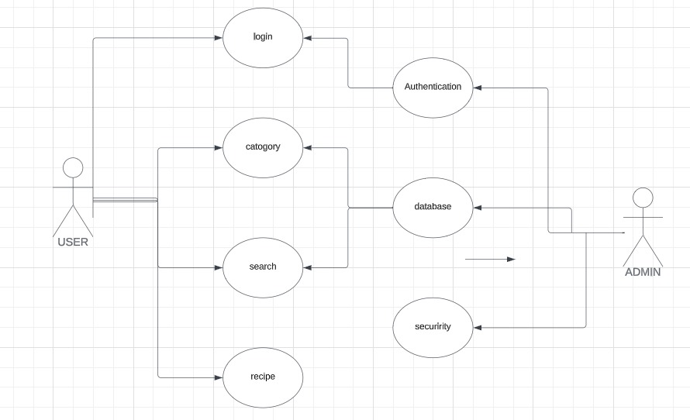

## Product Function

Entity Relationship Diagram of Recipe Recommendation System

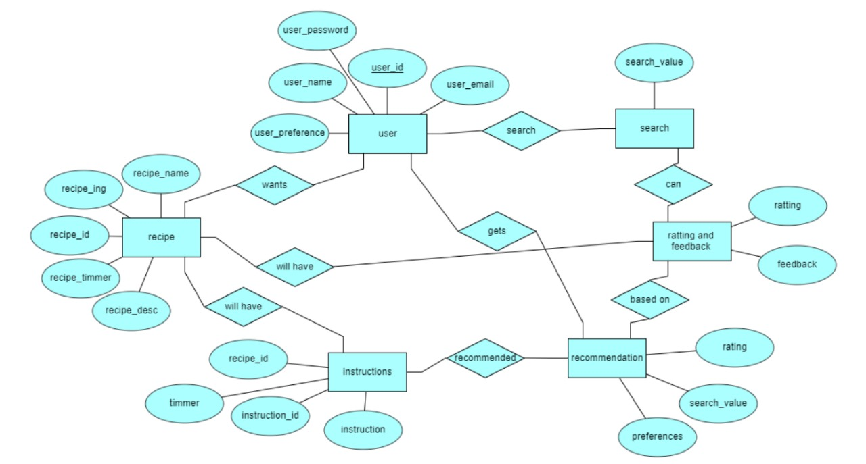

The main purpose of this project is to reduce the manual work. This software is capable of managing . An Entity-Relationship Diagram (ERD) models the relationships between entities in a system. In the context of a Recipe Recommendation System, key entities may include User, Recipe, Ingredient, Category, and Feedback. Below is a simplified ERD for a Recipe Recommendation System: The valid members are also allowed to view their account information.

## User Classes and Characteristic

The system provides different types of services based on the type of users [Vegetarian / Non-Vegetarian]. Recipe recommendation apps typically offer a range of features to enhance the user experience and provide personalized suggestions based on individual preferences. Here are common features found in recipe recommendation apps:

* + - Users can create accounts, providing basic information and preferences. They can manage and update their profiles over time.
    - Users can set and update their food preferences, dietary restrictions, and allergies to receive tailored recipe recommendations.
    - Personalized recipe suggestions based on user preferences, previous interactions, and liked/disliked recipes.
    - Users can search for recipes using keywords, ingredients, or filters (e.g., cuisine type, cooking time, difficulty level)
    - Detailed information for each recipe, including ingredients, step-by-step instructions, nutritional information, and user reviews.
    - Users can save recipes they want to try or mark them as favorites for quick access.
    - Tools for planning meals, creating shopping lists, and scheduling recipes for specific days.
    - Integrated timers to help users keep track of cooking times for various recipe steps.
    - Users can rate and review recipes, providing feedback for others in the community.
    - Downloadable recipes for offline access, useful for users without a constant internet connection.

## Operating Environment

The product will be operating in windows environment. The Library Recipe Recommendation System is a website and shall operate in all famous browsers, for a model we are taking Microsoft Internet Explorer,Google Chrome,and Mozilla Firefox.Also it will be compatible with the IE 6.0. Most of the features will be compatible with the Mozilla Firefox & Opera 7.0 or higher version. The only requirement to use this online product would be the internet connection.

The hardware configuration include Hard Disk: 40 GB, Monitor: 15” Color monitor, Keyboard: 122 keys. The basic input devices required are keyboard, mouse and output devices are monitor, printer etc.

## Assumptions and Dependencies

The assumptions are:-

* + - The coding should be error free
    - The system should be user-friendly so that it is easy to use for the users
    - The information of all users, books and libraries must be stored in a database that is accessible by the website
    - The system should have more storage capacity and provide fast access to the database
    - The system should provide search facility and support quick transactions
    - The Recipe Recommendation System is running 24 hours a day
    - Users may access from any computer that has Internet browsing capabilities and an

Internet connection

* + - Users must have their correct usernames and passwords to enter into their accounts and do actions

The dependencies are:-

* + - The specific hardware and software due to which the product will be run
    - On the basis of listing requirements and specification the project will be developed and run
    - The end users (admin) should have proper understanding of the product
    - The system should have the general report stored
    - The information of all the users must be stored in a database that is accessible.
    - Any update regarding the recipe is to be recorded to the database and the data entered should be correct

## Requirement

Software Configuration:-

This software package is developed using java as front end which is supported by sun micro system. Microsoft SQL Server as the back end to store the database.

Operating System: Windows NT, windows 98, Windows XP Language: Java Runtime Environment, Net beans 7.0.1 (front end) Database: MS SQL Server (back end)

Hardware Configuration:- Processor: Pentium(R)Dual-core CPU Hard Disk: 40GB

RAM: 256 MB or more

## Data Requirement

The inputs consist of the query to the database and the output consists of the solutions for the query. The output also includes the user receiving the details of their accounts. In this project the inputs will be the queries as fired by the users like create an account, selecting recipe and putting into account. Now the output will be visible when the user requests the server to get details of their account in the form of time, date and which recipe are currently in the account.

# External Interface Requirement

## GUI

The software provides good graphical interface for the user and the administrator can operate on the system, performing the required task such as create, update, viewing the details of the book.

* + - Regular updates and expansions to the recipe database can be performed seamlessly within the graphical interface.
    - The graphical interface is customizable to suit the preferences of administrators, allowing for a personalized user experience.
    - All modules provided within the software adhere to a standardized design, creating a cohesive and unified visual experience.
    - The design philosophy prioritizes simplicity, ensuring that interfaces are user-friendly and easy to navigate for administrators.
    - The interface seamlessly interacts with the user management module, facilitating efficient management of user accounts.
    - A dedicated part of the interface is allocated to the login/logout module, ensuring a secure and streamlined authentication process for administrators.

Login Interface:-

In case the user is not yet registered, he can enter the details and register to create his account. Once his account is created he can ‘Login’ which asks the user to type his username and password. If the user entered either his username or password incorrectly then an error message appears.

Search:-

The User can enter the type of food he is looking for and the meal he is interested in, then he can search for the required dish by entering the dish name.

Categories View:-

Categories view shows the categories of food available and provides ability to the user to add/edit or delete category from the list.

# System Features

The users of the system should be provided the surety that their account is secure. This is possible by providing:-

* User authentication and validation of members using their unique member ID
* Proper monitoring by the administrator which includes updating account status
* Proper accountability which includes not allowing a member to see other member’s account.
* Only administrator will see and manage all member accounts
* Provide users with advanced search options and filters, including cuisine type, dietary preferences, difficulty level, and ingredients.
* Utilize algorithms to analyze user behavior and preferences, delivering personalized recipe suggestions.
* Allow users to rate and review recipes they have tried

# Other Non-functional Requirements

## Performance Requirement

The Performance requirements for a recipe recommendation system are crucial to ensure that the system operates efficiently and provides a satisfactory user experience. Therefore, it is expected that the database would perform functionally all the requirements that are specified by the user.

Here are key performance requirements:

* + - The performance of the system should be fast and accurate
    - The recipe Recommdendation System shall handle expected and non-expected errors in ways that prevent loss in information and long downtime period. Thus it should have inbuilt error testing to identify invalid username/password
    - The system should be able to handle large amount of data. Thus it should accommodate high number of books and users without any fault

## Safety Requirement

The database may get crashed at any certain time due to virus or operating system failure. Therefore, it is required to take the database backup so that the database is not lost. Proper UPS/inverter facility should be there in case of power supply failure.

## Security Requirement

* + - System will use secured database
    - Normal users can just read information but they cannot edit or modify anything except their personal and some other information.
    - System will have different types of users and every user has access constraints
    - Proper user authentication should be provided
    - No one should be able to hack users’ password
    - There should be separate accounts for admin and members such that no member can access the database and only admin has the rights to update the database.

## Requirement attributes

* + - There may be multiple admins creating the project, all of them will have the right to create changes to the system. But the members or other users cannot do changes
    - The project should be open source
    - The Quality of the database is maintained in such a way so that it can be very user friendly to all the users of the database
    - The user be able to easily download and install the system

## Business Rules

A business rule is anything that captures and implements business policies and practices. A rule can enforce business policy, make a decision, or infer new data from existing data.This includes the rules and regulations that the System users should abide by. This includes the cost of the project and the discount offers provided. The users should avoid illegal rules and protocols. Neither admin nor member should cross the rules and regulations.

## User Requirement

The users who act as administrator to maintain the system. The members are assumed to have basic knowledge of the computers and internet browsing. The administrators of the system should have more knowledge of the internals of the system and is able to rectify the small problems that may arise due to disk crashes, power failures and other catastrophes to maintain the system. The proper user interface, user manual, online help and the guide to install and maintain the system must be sufficient to educate the users on how to use the system without any problems.

The admin provides certain facilities to the users in the form of:-

* + - Backup and Recovery
    - Forgot Password
    - Data migration i.e. whenever user registers for the first time then the data is stored in the server
    - Data replication i.e. if the data is lost in one branch, it is still stored with the server
    - Auto Recovery i.e. frequently auto saving the information
    - Maintaining files i.e. File Organization
    - The server must be maintained regularly and it has to be updated from time to time

# Other Requirements

## Data and Category Requirement

To develop an effective recipe recommendation system, a robust dataset and comprehensive categorization are crucial components. The dataset should encompass detailed information on ingredients, cooking instructions, nutritional content, cuisine types, and difficulty levels for a diverse array of recipes. Additionally, user-related data such as taste preferences, dietary restrictions, ratings, and favorite recipes play a pivotal role. Contextual information, including seasonal relevance, time of day, and weather considerations, further refines the system's recommendations. A well-defined category taxonomy, encompassing meal types, cuisine categories, ingredients, and occasions, facilitates accurate categorization and personalized suggestions. Implementing sophisticated search and recommendation algorithms, such as collaborative and content-based filtering, enhances the system's accuracy. Data quality and integration from diverse sources ensure the system's reliability, while a user-friendly interface and robust privacy measures contribute to a positive user experience. Incorporating mechanisms for user feedback allows continuous improvement, refining the system's recommendations over time. Overall, a holistic approach to data and category requirements ensures a recipe recommendation system that meets the varied preferences and needs of users effectively.

## Appendix

A: Admin, Abbreviation, Acronym, Assumptions; B:Business rules; C: Class, Client, Conventions; D: Data requirement, Dependencies; G: GUI; K: Key;M: Member; N: Non-functional Requirement; O: Operating environment; P: Performance,Perspective,Purpose; R: Requirement, Requirement attributes,Recipe; S: Safety, Scope, Security, System features; U: User, User class and characteristics, User requirement;

## Glossary

The following are the list of conventions and acronyms used in this document and the project as well:

* + - Administrator: A login id representing a user with user administration privileges to the software
    - User: A general login id assigned to most users
    - Client: Intended users for the software
    - SQL: Structured Query Language; used to retrieve information from a database
    - SQL Server: A server used to store data in an organized format
    - Layer: Represents a section of the project
    - User Interface Layer: The section of the assignment referring to what the user interacts with directly
    - Application Logic Layer: The section of the assignment referring to the Web Server. This is where all computations are completed
    - Data Storage Layer: The section of the assignment referring to where all data is recorded
    - Use Case: A broad level diagram of the project showing a basic overview
    - Class diagram: It is a type of static structure diagram that describes the structure of a system by showing the system’s cases, their attributes, and the relationships between the classes
    - Interface: Something used to communicate across different mediums
    - Unique Key: Used to differentiate entries in a database

## Class Diagram

A class is an abstract, user-defined description of a type of data. It identifies the attributes of the data and the operations that can be performed on instances (i.e. objects) of the data. A class of data has a name, a set of attributes that describes its characteristics, and a set of operations that can be performed on the objects of that class. The classes’ structure and their relationships to each other frozen in time represent the static model. In this project there are certain main classes which are related to other classes required for their working. There are different kinds of relationships between the classes as shown in the diagram like normal association, aggregation, and generalization. The relationships are depicted using a role name and multiplicities.

